Problem Statement:

Write a Hive Program to find the total number of medals each country won

To get answer to this query we have loaded the Olympic data in a table Olympic. To get the number of medals won by each country we have grouped by using country and summed total medal column.

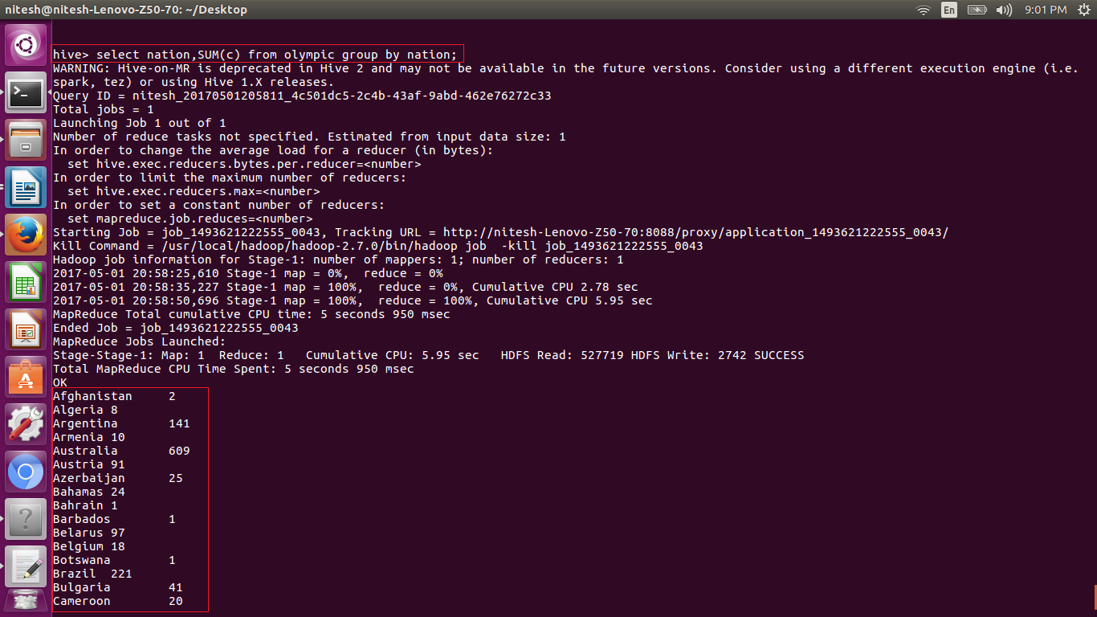





Problem Statement:

Write a Hive program to find the number of gold medals each country won

To get answer to this query we have loaded the Olympic data in a table Olympic. To get the number of gold medals won by each country we have grouped by using country and summed gold medal column.

